User Requirement Specification (URS)

Real-time Analytical Monitoring Application (RAM)

|  |  |  |  |
| --- | --- | --- | --- |
|  | |  | |
| Document Reference: | | RAM/TURS | |
| Project: | | Real-time Analytical Monitoring Application | |
| Document Title: | | Real-time Analytical Monitoring Application (RAM) User Requirement Specification (URS) | |
| Version: | | 1.0 | |
| Date: | | 23 April 2018 | |
| Author:  Reviewers:  Approved and Signed off by: | | Balasubramanian Narasimhan (PT07 ISS)  Kaung Myat Bo (PT07 ISS)  Treza Bawm Win (PT07 ISS)  Gao Zhiyu (PT07 ISS)  Nay Lin Aung (PT07 ISS)  <PH> (SERIS) | |
|  | |  | |
|  | |  | |
|  | |  | |
|  | |  | |
|  | |  | |
|  | |  | |
|  | |  | |
|  | |  | |
| **©** 2001  The information contained in this document is the property of ISS. The contents must not be copied in whole or in part for purposes other than which it has been supplied without the consent of ISS, or, if it has been furnished under contract to another party, as expressly authorised under that contract, then ISS shall not be liable for any errors or omissions. |  |
| ***Institute of Systems Science, 25 Heng Mui Keng Terrace,***  ***Singapore 119615*** | |

Version History Record

|  |  |  |  |
| --- | --- | --- | --- |
| Version | Review & Approval Form Number | Date | Brief description of amendments and affected pages, paragraph |
| 1.0 | RAM/TURS | 18/4/2018 | First Issue |
| 2.0 | RAM/TURS |  |  |
| 3.0 | RAM/TURS |  |  |
|  |  |  |  |
|  |  |  |  |

Table of Contents

1. INTRODUCTION 5

1.1 Background 5

1.2 Objectives 5

1.3 Organization 5

1.4 Scope 5

1.5 Definition of Terms 5

1.6 Definitions, acronyms and abbreviations 6

2. OVERVIEW OF REQUIREMENTS 7

2.1 Introduction 7

2.2 System Perspective 7

2.3 System Functions 8

2.4 System Characteristics 8

2.5 User Characteristics 8

2.6 General Constraints and Assumptions 9

3. FUNCTIONAL REQUIREMENTS 10

3.1 Functional Requirements 12

3.2 User Interface Requirements 15

# INTRODUCTION

## Background

The Solar Energy Research Institute of Singapore (SERIS) conducts research, development, testing and consulting on solar energy technologies and their integration into power systems and buildings. SERIS is globally active but focuses on technologies and services for tropical regions, in particular for Singapore and South-East Asia.

The aim of the project is to develop a cloud-based platform for integrating and managing real-time Analytical Monitoring of PV systems performance - from small rooftop systems to large ground-based PV power plants in the multi-MW range across different climate zones. Collected data will be used for extensive research programmes on yield projections, which are of vital importance to project developers as well as investors and degradation studies of PV modules & systems.

The work is organized in 3 different projects

1. Web portal – A web portal for users to access the application components
2. Central Data Management – A cloud based application that can record, transform and report the data sent from PV systems.
3. SERIS Interface – The interface between the application and SERIS central monitoring system which. This interface enables communication and interaction between the proposed application and the SERIS Central Monitoring system

This document is to present the user requirement specification for the Real-time Analytical Monitoring Application – RAM, i.e. the project

## Objectives

The objectives of this document are to:

1. define the functional requirements for the Real-time Analytical Monitoring Application;
2. define the non-functional (i.e. operational and quality) requirements that would be necessary to support the functional requirements;
3. identify the necessary requirements that would facilitate the future modification of the application and
4. Provide the basis for the development of the system.

## Organization

Section 1 gives an introduction to this document. Section 2 presents an overview of requirements for the system or application. The functional requirements are presented in Section 3 and section 4 describes the operational and quality requirements.

## Scope

This user requirement specification is solely concerned with the development of the Real-time Analytical Monitoring Application and identifying the necessary requirements that would facilitate the future modification of RAM application. For the purpose of this document the Real-time Analytical Monitoring Application is referred as the application or simply ‘RAM’ interchangeably but both refer to the same.

The financing, availability and provisioning of the AWS Service components are agreed to be handled and taken care by the client, i.e. SERIS.

<PH><Out-of-scope>

## Definition of Terms

The following terms have special meanings within this document:

1. The word ***shall*** implies a mandatory requirement.
2. The word ***should***implies a desirable requirement.
3. The word ***will*** implies a mandatory requirement outside the scope of this document.
4. The word ***may*** implies a desirable requirement outside the scope of this document.

## Definitions, acronyms and abbreviations

The following terms have special meanings within this document:

* Acronyms and abbreviations
* SERIS – Solar Energy Research Institute of Singapore
* RAM – Real-time Analytical Monitoring
* RAMA – Real-time Analytical Monitoring Application
* PV – Photovoltaic, systems that converts solar energy into electrical energy
* IoT – Internet of Things
* CMS – Central Monitoring System, The SERIS/in-house central monitoring system
* Definitions
* Devices – The PV systems that are required to be monitored
* Sensors – The sensors attached to each of these devices that constantly measure certain characteristics.
* Station – A station holds a set of devices that needs to be monitored. These devices are said to be tagged to that specific station.
* Web Portal – The component of the system that can be accessed via a browser by end user
* Cloud Computing - Cloud computing is an information technology (IT) paradigm that enables ubiquitous access to shared pools of configurable system resources and higher-level services that can be rapidly provisioned with minimal management effort, often over the Internet. Cloud computing relies on sharing of resources to achieve coherence and economies of scale, similar to a public utility

# OVERVIEW OF REQUIREMENTS

## Introduction

The aim of the project is to develop a cloud-based platform for integrating and managing real-time Analytical Monitoring of PV systems performance - from small rooftop systems to large ground-based PV power plants in the multi-MW range across different climate zones. Collected data will be used for extensive research programmes on yield projections, which are of vital importance to project developers as well as investors and degradation studies of PV modules & systems. Following are the three main streams of the project

1. Web portal – A web portal for users to access the application components
   1. User Management
   2. Device and Station configurations
   3. Report configuration
2. Central Data Management – A cloud based application that can record, transform and report the data sent from PV systems.
   1. Data Capture – Cloud based components that captures and records the incoming data (unstructured) sent from sensors
   2. Transformation – Cloud based components that transform and records the unstructured data into structured data for further analytics and reporting purposes
   3. Reporting – Cloud based reporting component that performs back-end analytical calculations and make it available for both front-end reporting and as well as for interfacing with SERIS’s in-house central monitoring system
3. SERIS Interface – The interface between the application and SERIS central monitoring system which. This interface enables communication and interaction between the proposed application and the SERIS Central Monitoring system

## System Perspective

The current application is actually an incremental development of the whole application. They were developed as smaller increments to an existing code. One has to manually intervene and re-write most or part of the code as and when a new device is to be incorporated into SERIS landscape. This could be a simple configuration change which could involve minor changes to the existing code. On the other hand it could drive a drastic change to the existing code to suit to a specific new device to be introduced into SERIS landscape. The primary objective of the system is to have soft configurable parameters that allow introducing and integrating new devices with in the SERIS landscape. Following are some of the high level benefits to be delivered by the proposed system.

* Single and Centralized platform for users to process the structured data from remote stations.
* Automated data capture for the structured and semi structured parameters.
* Interface with other backend systems within the organization, in this integration with SERIS central monitoring system.
* Audit trail capability of the incoming data
* Transformation of unstructured data into structured data
* Analytical reporting of the stations and devices

## System Functions

System functions to be implemented are:

1. Browser Interface – Access to the application via standard browser interface
2. User Login & Access control – Relevant components are exposed and are accessible by the user, delivering effective user access.
3. Application Administration – Perform setup, configuration and other supervisory / administrative functions to be carried out by the administrators, primarily focused on application level components
4. User Management
5. User Role Management
6. Device Management
7. Device Group Management
8. Station Management
9. Persona Management
10. System Administration – Perform setup, configuration and other supervisory / administrative functions to be carried out by the administrators, primarily focused on system / infrastructure level components
11. System Setup
12. System Configuration Management
13. Central Data Management
14. Data Capture
15. Transformation
16. Reporting
17. Interface to SERIS/Central Monitoring System

## System Characteristics

The system has below listed characteristics

* RAM to be built on Cloud technology to offer high degrees of agility and the ability to collect high volumes of data in real time
* RAM allows PV system device(s) to generate very high volumes of unstructured data. This could typically be unstructured data sent at every second and every minute interval(s) from a variety of devices and store it in Cloud Database. These devices are spread across various industrial and remote sites that will stream data into the application which is to be stored with in the cloud database infrastructure
* RAM allows admins to configure and incorporate cloud-based system to reduce the cost of maintaining servers, to avoid data losses and to simultaneously access the system from multiple internet connected devices (computer, tablet, mobile phone)
* A default admin (super-user) user account will be setup during the installation. The admin will come with a set of pre-configured rights and privileges. Unlike other user accounts this account cannot be deleted/deactivated from the system.

## User Characteristics

The users have below listed characteristics

* Users will use the application via browser interface. The browser version supported are Chrome, Mozilla Firefox, Safari, Microsoft Edge, and Internet Explorer 11 and above. In general we expect the client to upgrade their browser to recent version if not the latest version to maintain compatibility with the application.
* A user can only login from at most one system at any point in time. Concurrent login for the same user is not allowed, in which case the previous session will be automatically logged out

## General Constraints and Assumptions

The following are certain general assumptions and constraints of the intended application.

* Base version of application with following set of interfaces will be available.
* All partner systems will provide the required interface to integrate with Cloud based Real-time Analytical Monitoring of Photovoltaic Systems.
* Required Hardware and Software infrastructure will be made available in SERIS. The server and database are stored, managed and maintained by the SERIS, which is also responsible for maintaining the system and ensuring its qualification.
* The Sensors and Readers is installed at the Remote site, but the software, server and database are hosted by the system. The data are collected, stored and managed by the system whilst the SERIS has access to the data through a secure web interface.
* Application Development would be done by the MTECH SE25-PT07.
* Sensors should have a built-in data storage capability so that they can also act as data loggers. Sensors continuously collect and buffer data, even during network outages and power cuts. The buffered data should then be sent to the host server when the connection is re-established.

<PH-Out-of-scope>

# FUNCTIONAL REQUIREMENTS

This section describes the functional requirements of the RAMA. Figure 1 below present an overview of the system, showing the main components of the application and the roles of the users.

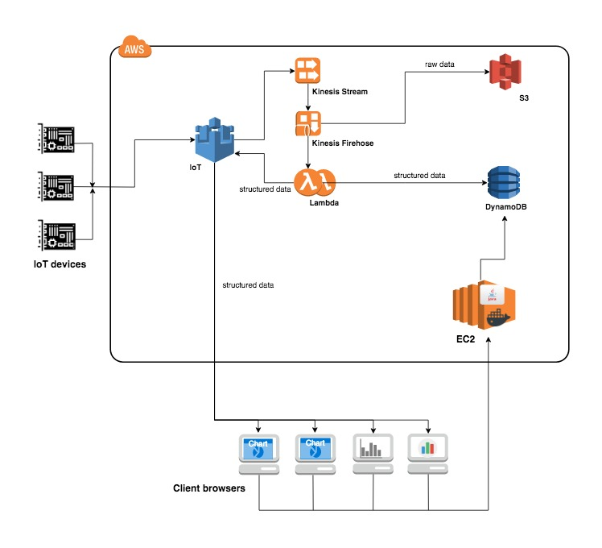

Figure 1: System Overview

The below is Requirements level Use Case Model for the Application for understanding the features application will provide.

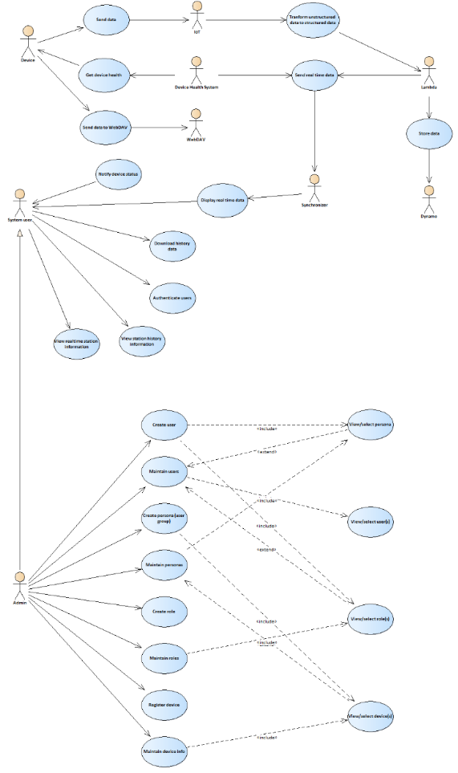

Figure 2: Primary Use Cases

## Functional Requirements

This section describes in brief on the functional requirements of RAM. Although the technical requirement does not cover each and every aspect of the intended functionality at this point in time; it does give an overview of the functionality to be implemented by RAM application. The implementation details of the functionality may change based on the implementation technology choice, infrastructure and software components.

### Browser Interface

Users access the application’s web-portal via a standard browser interface with an active internet connection. The web-portal should be user-friendly and is capable of performing complex operations by accessing the data stored in the cloud.

### User Login and User Access Mapping

The system allows authorised user(s) to access the application. The user is required to provide username and password. It specifies the access and usage privileges of authenticated users and client applications.

After authentication user will have access to main menu. Availability of menu functions depends on user’s level of access.

The system allows access to relevant application components and functionalities based on the users permissions. This function allows the user with appropriate permissions to combine list of Devices/locations into a group

### Application Administration

Perform setup, configuration and other supervisory / administrative functions to be carried out by the administrators, primarily focused on application level components

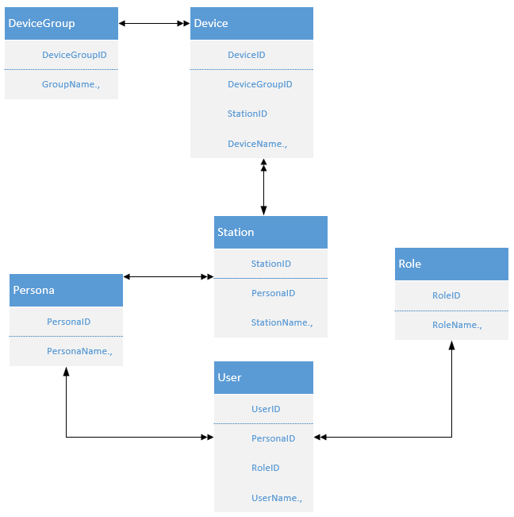

Figure 3: Application Administration Components

#### **User Management**

The System should allow the Users to create, edit, copy and delete Individual Users, who will login and access the application.

Further the System should allow the Users to create, edit, copy and delete User Groups. A user group is set of (one or more) individual users tagged together. That way the admins can manage the access rights at group level rather than at individual user level.

#### **User/Access Control Mapping**

The system allows admins an easy and organized way of mapping permissions to users, via roles. The System should allow the Users to maintain roles to be assigned to the business users. It is through these Roles that the User Permissions are controlled. As a first step you must maintain at least an administrator role.

The System allows the user with appropriate permission to browse list of all roles existing in the system

#### **Device Management**

The System should allow the Users to create, edit, copy and delete IoT devices that are to be monitored by the application.

The System allows the user with appropriate permission to browse list of all devices existing in the system

#### **Device Group Management**

Each device comes with a set of parameters that they can monitor and send it to the RAM application. As set of devices that share similar characteristics can be tagged to device group and the device group in-turn maintains these configuration parameters.

The System should allow the Users to create, edit, and delete device groups to which an IoT device must to be tagged-to within the application.

The System allows the user with appropriate permission to browse list of all device groups present in the system.

#### **Station Management**

A station is a site that has a set of IoT devices tagged to them. The System should allow the Users to create, edit, and delete stations to which the IoT devices are tagged to within the RAM application.

The System allows the user with appropriate permission to browse list of all stations existing in the system

#### **Persona Management**

A group of stations collectively administered/monitored is called a PERSONA. Each persona can have one or more stations tagged to them. The users are then tagged one these personas. The System should allow the Users to create, edit, and delete PERSONAs to which the stations are mapped to within the RAM application.

The System allows the user with appropriate permission to browse list of all PERSONAs present in the system

### System Administration

Perform setup, configuration and other supervisory / administrative functions to be carried out by the administrators, primarily focused on system / infrastructure level components

#### **System Setup**

The System allows to be built on Cloud technology to offer high degrees of agility and the ability to collect huge volumes of data from the enterprise and beyond. This function facilitates the initial setting up of the application’s high level infra-structure components and its details.

#### **System Configuration Management**

The System allows admins to configure and incorporate cloud-based monitoring system to reduce the cost of maintaining servers, to avoid data losses and to access the system from multiple internet connected devices (computer, tablet, mobile phone) in parallel manner

### Central Data Management

A central component of the application which manages

* Incoming data from IoT devices
* Transformation of raw data into structured data
* Preparation of analytical data and Reporting requirements

#### **Data Capture**

The System allows capturing unstructured data sent from IoT devices in real-time.

#### **Transformation**

The System allows these unstructured data to be formatted into structured data format based on the device parameters configuration. The system records structured data accurately and in real-time.

#### **Reporting**

The structured data should be available and accessible by users in the form of reports, charts, and graphs. The users are able to customize these reports further.

The raw/un-structured data should be available and accessible by users, and they will be given an option to download the raw data.

#### **System Alerts**

The RAM Application will send certain alerts to notify the users of important or time-sensitive information captured by the application.

Users have requested that an alert be triggered and sent in case of device failures. The application will receive device failure information in real-time from an external device monitoring application managed by SERIS. The RAM application in-turn makes use of this information to trigger an alert and notify the user of such device failures.

### Interface to SERIS/Central Monitoring System

The system should be designed to allow an interface to be built to SERIS’s Central Monitoring System.

## User Interface Requirements

The 'User Interface specification' is documented and available as a separate document in ‘\SPEC\REQUIREMENT\UIS\UIS.docsx’.